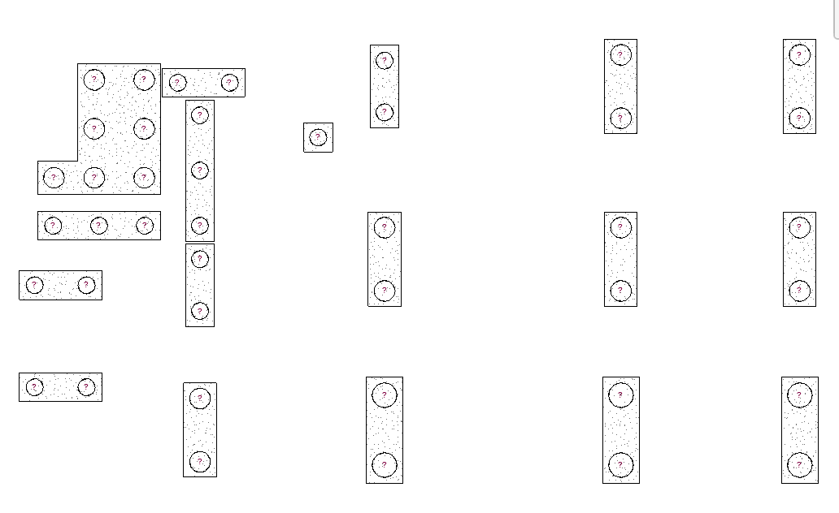

Working of script

1. Firstly, the script sort the pile caps on basis of x-coordinate first and then y-coordinate.
2. And then group the piles on basis of pile cap.
3. Then number the piles within the sorted pile Cap.

